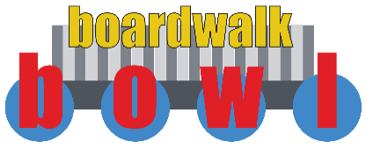
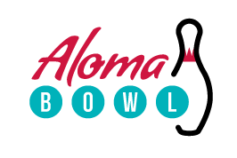
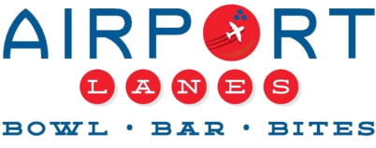

Aloma Bowling Centers offer specials, contest
for March Mayhem

Guests can score slam dunk deals on beer, wings throughout NCAA tournament

ORLANDO, Fla. (Feb. XX, 2019) – From the upsets and Cinderella stories to the thrill of a perfect bracket, there’s nothing quite like basketball in March. This year, the Aloma Bowling Centers are taking the madness off the court and to the lanes!

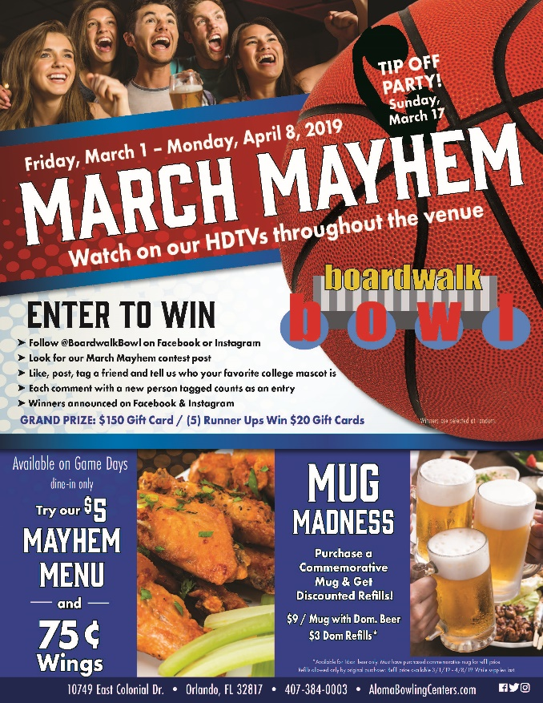
Airport Lanes in Sanford, Aloma Bowl in Winter Park and Boardwalk Bowl in Orlando will be your NCAA tournament headquarters with crazy-good food and drink deals, HDTVs throughout the venues and chances to win.

The mayhem starts on March 1 with the fan favorite Mug Madness. Guests can purchase a commemorative mug and 16 oz. domestic beer for $9 and enjoy $3 domestic refills throughout March Mayhem.

Guests can also fuel up on game days with a special menu. Signature items, such as South of the Border Mac & Cheese and Bacon Jalapeño Street Dog, will be available for only $5. Finally, all three venues will offer 75-cent wings on game days throughout the tournament.

And while your favorite team battles it out on the court, you can compete, too! Each Aloma Bowling Centers venue will run a social media contest throughout March Mayhem. To enter, simply follow Boardwalk Bowl, Aloma Bowl or Airport Lanes on Facebook or Instagram. Keep an eye out for our March Mayhem contest post then like, post, tag a friend and tell us who your favorite college mascot is. Each comment with a new person tagged counts as an entry. One winner will take home the grand prize, a $150 gift card, and five runners up will receive a $20 gift cards.

March Mayhem will officially begin with a Tip Off Party on Sunday, March 17—but the Aloma Bowling Centers will start The Big Dance early, with deals available from March 1 through the National Championship on April 8.

For more information, visit http://www.alomabowlingcenters.com.

About Aloma Bowling Centers
The Aloma Bowling Centers are the premier family entertainment venues in Central Florida, with locations in Orlando (Boardwalk Bowl Entertainment Center), Winter Park (Aloma Bowl) and Sanford (Airport Lanes). In addition to the 144 combined lanes, each center offers billiards, a restaurant, and arcades featuring new interactive games. All venues offer great corporate and group event/party facilities. Boardwalk Bowl Entertainment Center houses 80 lanes, making it the largest bowling facility in the Southeast. For more information, visit AlomaBowlingCenters.com or call 407-384-0003 (prompt 1).

Media Contact
Will Wellons
Wellons Communications
407-339-0879
will@wellonscommunications.com

